Overall Game Play:

You rotate the back ground, changing directions of gravity in order to get through the door which completes each level.

Progress: Complete levels

The game’s designed age range is 12-60

Story:

なに

おまいわもしんている

Techniques:

: Jump

: Move left

: Move right

Left Arrow: Move world to the left

Right Arrow: Move world to the right

In game objects:

Harmless:

Platforms: you can stand on them and they are not controlled by gravity

Blocks: you can stand on them and they are affected by gravity

Switch: Turn on the switch to open objects

Doors: Open doors to get through level or space

Buttons: Works same as switch but has delay after

One-Step-Platform: Restores after a couple seconds

Sticky Surface: You are stick to the surface and not affected by gravity.

Gravitational space: A space that when you are in it, the gravitational pull towards you is less.

Harmfull:

Spikes: Stay at one spot and kills you if you touch it

Falling spikes: Can be affected by gravity

Moving spikes: Spikes that move around

Cpu: Cannot be killed and moves around in a certain path (Moving turrets)

Level groups:

For each level, the gravity direction changes and gravity strength changes

Challenges

Challenges are things that give you a certain mission for a level. If you complete the mission with the challenges completed you are rewarded with trophies.

Challenges:

Time: Finish the mission in a certain amount of time.

Switch scenes: Finish the mission by switching certain times of gravity

Zero death: self explanatory

Levels

Level 1:

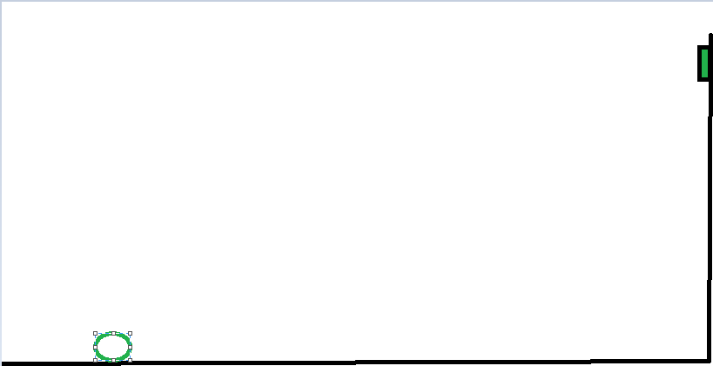

Level 2:



Level 3:

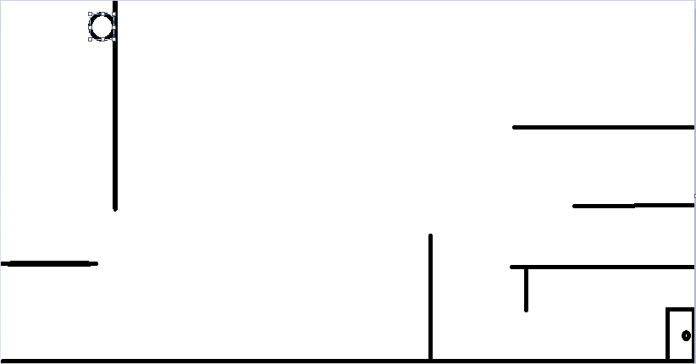

Level 4:

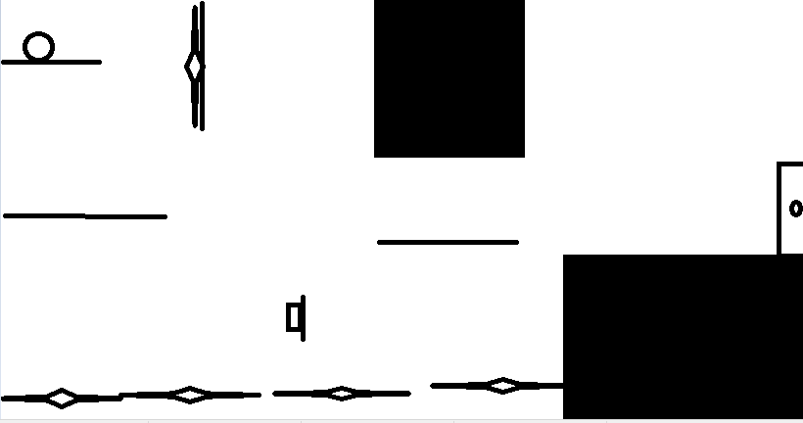

Level 5

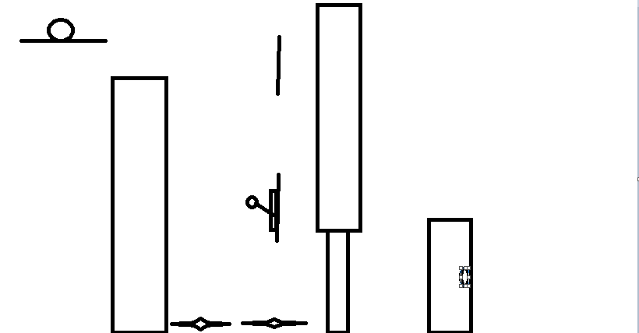

Level 6: